Classic Imperial Topaz. Size: 5 by 2.5 cm. Locality: Saramenha, Brazil. Collection: William Larson

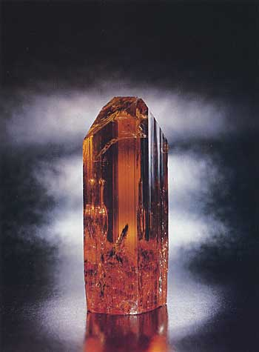

How do I know if a topaz is “Imperial topaz”?
There is no official standard for imperial topaz. Some dealers use the term for colors that are orange to pink to red to purple, others reserve the term for certain saturated shades. It’s the color, not the term “Imperial” that gives topaz its value.

Extract from Gemselect website

Imperial Topaz Colour
Originally, imperial topaz was classified as orange with red dichroism. Nowadays imperial topaz is defined more widely to include yellow, pink, red, lavender-pink and peach-pink. Sometimes, the colour of imperial topaz can gradually fade over time, when exposed to sunlight
Extract from The collector website
The name “imperial topaz” is said to have originated in the 19th century in Russia, where the Ural Mountain mines were an important source. According to some sources, pink topaz from those mines was restricted to the family of the Czar. Today, the gem trade generally uses the term for pink, orange and red topaz, which comes mainly from Ouro Prêto, Brazil. Fine pink topaz also comes from the Katlang area of Pakistan

