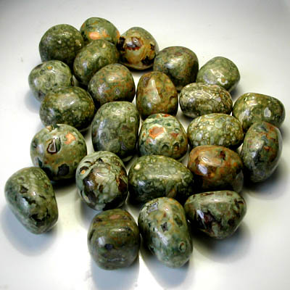[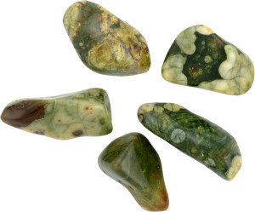](http://www.google.com.au/url?sa=i&rct=j&q=&esrc=s&source=images&cd=&cad=rja&uact=8&ved=0ahUKEwj068CquOXMAhXDHJQKHV4jAbUQjRwIBw&url=http://topkamni.ru/kamni/riolit-rodoxrozit-rodusit-rubellit.html&psig=AFQjCNGQi1nzzfqs4VsugbdH72_4h36jMQ&ust=1463723133814072)

**[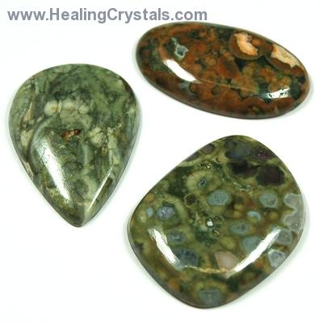](http://www.healingcrystals.com/Cabochons_-_Rainforest_Rhyolite_Cabochon__Free-Form___India_.html?images=all)**[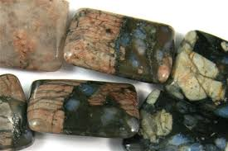](http://www.google.com.au/url?sa=i&rct=j&q=&esrc=s&source=images&cd=&cad=rja&uact=8&ved=0ahUKEwixiYrtuOXMAhUBopQKHVtlAy4QjRwIBw&url=http://www.beadian.com/store/gemstone-beads/blue-riolite/blue-riolite-18x25mm-puff-rectangle-shape-beads.html&psig=AFQjCNGQi1nzzfqs4VsugbdH72_4h36jMQ&ust=1463723133814072)

[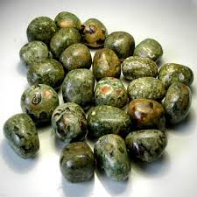](http://www.google.com.au/url?sa=i&rct=j&q=&esrc=s&source=images&cd=&ved=&url=http://www.puntominerali.it/dettaglio/catalog/product_info.php?products_id%3D592%26osCsid%3D3cb..&psig=AFQjCNGQi1nzzfqs4VsugbdH72_4h36jMQ&ust=1463723133814072&cad=rja)