http://www.beaverbayagateshop.com/Thomsonite%20Main%20Page.html

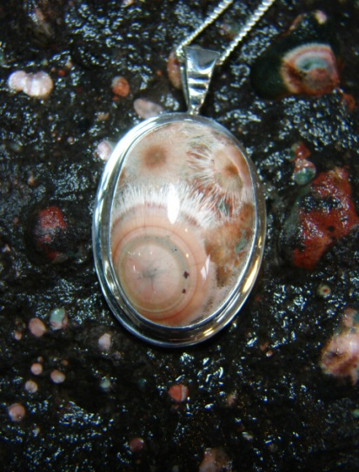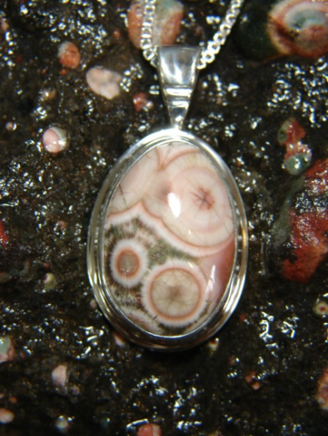

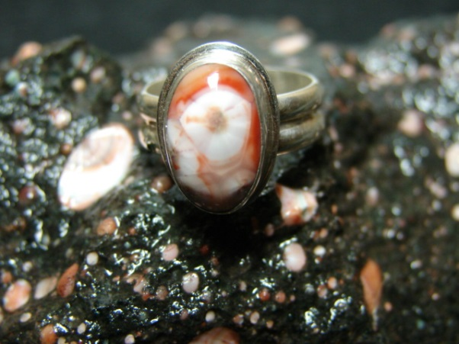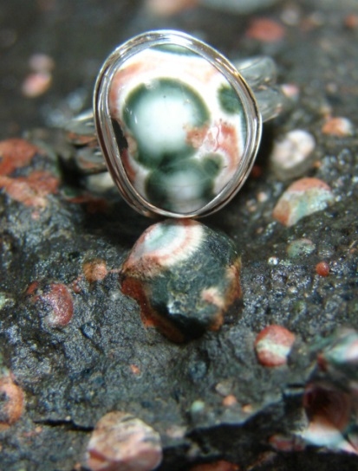

Thompsonite pendants for sale at Beaver Bay Agate Shop

Email: beaverbayagate@lakenet.com

